LINEAR SEARCH
#include <stdio.h>
#include <stdlib.h>
#define SIZE 10

int LinearSearch(int arr[],int n,int Key){
int i;
for(i=0; i<n; i++)
{
if(arr[i] == Key)
return i;
}
return -1;
}
int main()
{
int n,i,Key,result;

printf("Enter the Number of elements: ");
scanf("%d",&n);

int arr[n];
printf("Enter %d elements:\n",n);
for(i=0; i<n; i++){
scanf("%d",&arr[i]);
}

printf("Enter element to search: ");
scanf("%d",&Key);

result = LinearSearch(arr,n,Key);
if(result == -1)
printf("The search Key = %d is not in the Array\n",Key);
else
printf("The search Key = %d is at location = %d\n",Key,result+1);

return 0;
}
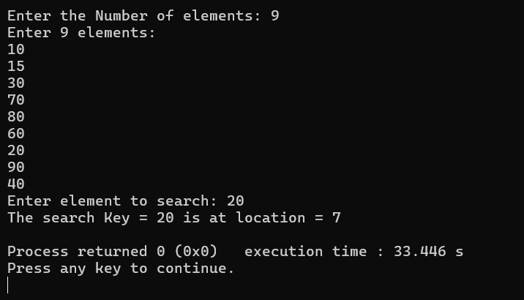
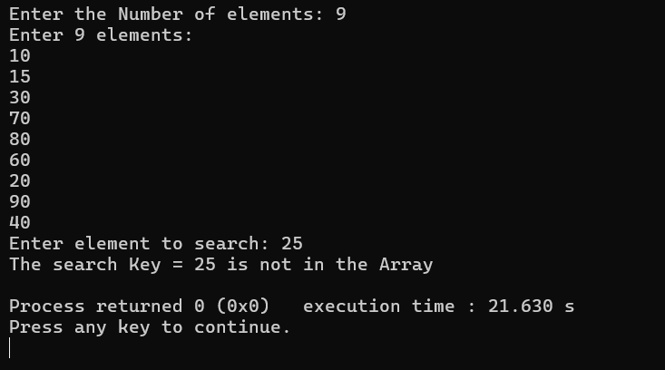
PHONEBOOK PROGRAM
#include <stdio.h>
#include <string.h>

int main()
{
int n, i;
printf("Enter number of contacts: ");
scanf("%d", &n);

char name[n][50];
long long phone[n];
char Email_ID[n][50];
char city[n][50];
char search[50];

for(i = 0; i < n; i++)
{
printf("\nEnter full name: ");
scanf(" %[^\n]", name[i]);

printf("Enter phone number: ");
scanf("%lld", &phone[i]);

printf("Enter Email ID: ");
scanf(" %[^\n]", Email_ID[i]);

printf("Enter City: ");
scanf(" %[^\n]", city[i]);
}

printf("\nEnter first name to search: ");
scanf(" %[^\n]", search);

int found = 0;

for(i = 0; i < n; i++)
{
if(strncmp(name[i], search, strlen(search)) == 0)
{
printf("\nContact Found!");
printf("\nName : %s", name[i]);
printf("\nPhone : %lld", phone[i]);
printf("\nEmail ID : %s", Email_ID[i]);
printf("\nCity : %s\n", city[i]);

found = 1;
}
}

if(found == 0)
printf("\nNo Contact Found!");

return 0;
}

OUTPUT:
